Developed by

Name : *Jasmine Nabila Novel*

*Yansiska*

Reg. No.:

**NIIT**

**PROJECT ON**

*Ebooks Online Web Based Application*

Batch Code :

Start Date *: April 11, 2018*

End Date : *April 18, 2018*

Name of Coordinator : *Riza Muhammad Nurman S.Kom.*

Name of Developer : *Jasmine Nabila Novel*

*Yansiska*

Date of Submission : *April 18, 2018*

**EBOOKS ONLINE WEB BASED APPLICATION**

**CERTIFICATE**

This is to certify that this report titled ***Ebooks Online Web Based Application*** embodies the original work done by ***Jasmine Nabila Novel and Ugi Ispoyo Widodo*** In partial fulfillment of their course requirement at NIIT.

Coordinator:

***Riza Muhammad Nurman , S.Kom***

**NIIT**

We have benefited a lot from the feedback and suggestions given to us by Mr. Riza Muhammad Nurman and other faculty members. We hope that this paper may have learning quality to the reader. Because mistakes are belong to us and perfectness only belong to Allah SWT. We are sorry if there are some mistakes or incomplete statements in this paper.

**ACKNOWLEDGEMENT**

**System Summary:**

College Enrollment Web Based Application is a web based application that provides for Ebooks Online

Admin can manage data, such as:

1. Process data Ebooks (view, create, update and delete).

The web application will also used by user to process the registration. In addition, the application will be used by prospective registrant to:

1. View List Ebook
2. Download PDF
3. Read Online Ebook

**SYSTEM ANALYSIS**

**Hardware :** System Computer with an Intel® Core™ i3-2310M

CPU @2.10GHz., 4,00 GB RAM

**Operating System :** Microsoft Windows 10 Ultimate with Service Pack 1

**Software :** NetBeans IDE 8.0, GlassFish Sever 4.1.1, SQL Server 2008,Astah Community

**HARDWARE AND SOFTWARE REQUIREMENTS**

**INDIVIDUAL PROJECT SCHEDULE**

|  |  |  |  |  |  |
| --- | --- | --- | --- | --- | --- |
| ***S.No*** | ***Activity Description*** | ***Planned Date of Completion*** | ***Actual Date*** | ***Responsibility*** | ***Remarks*** |
| *1* | *Creating the Login Page* | *13 April 18* | *13 April 18* | *Jasmine and Yansiska* |  |
| *2* | *Creating the Admin Page* | *11April 18* | *12 April 18* | *Jasmine and Yansiska* |  |
| *3* | *Creating User Page* | *14 April 18* | *15 April 18* | *Jasmine and Yansiska* |  |
| *4* | *Creating UML Diagrams* | *17 April 16* | *18 April 16* | *Jasmine and Yansiska* |  |

**SEQUENCE DIAGRAM**

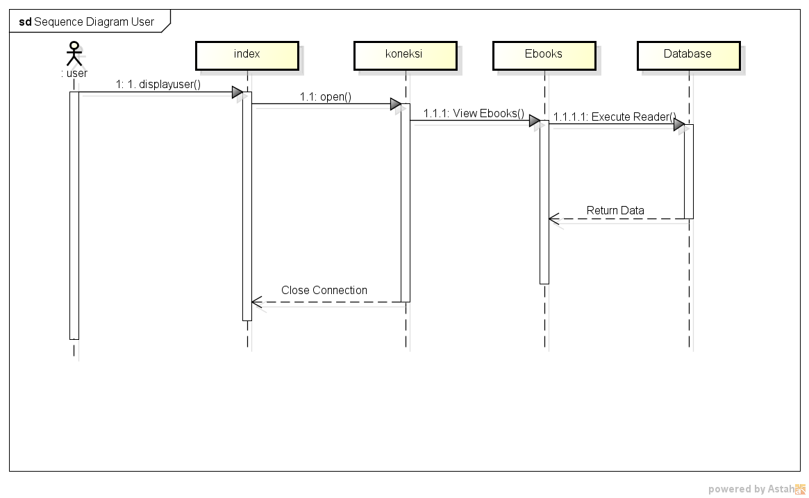

**ACTIVITY DIAGRAM LOGIN**

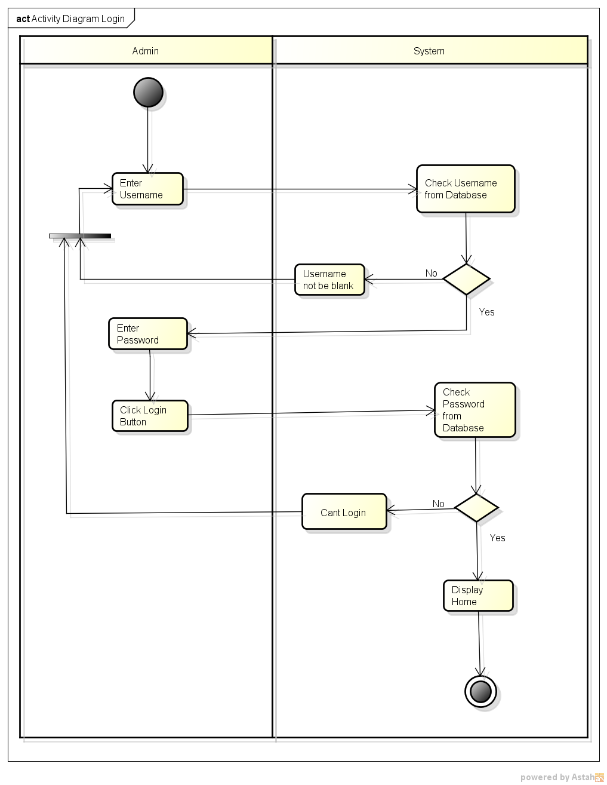

**ACTIVITY DIAGRAM ADD ADMIN**

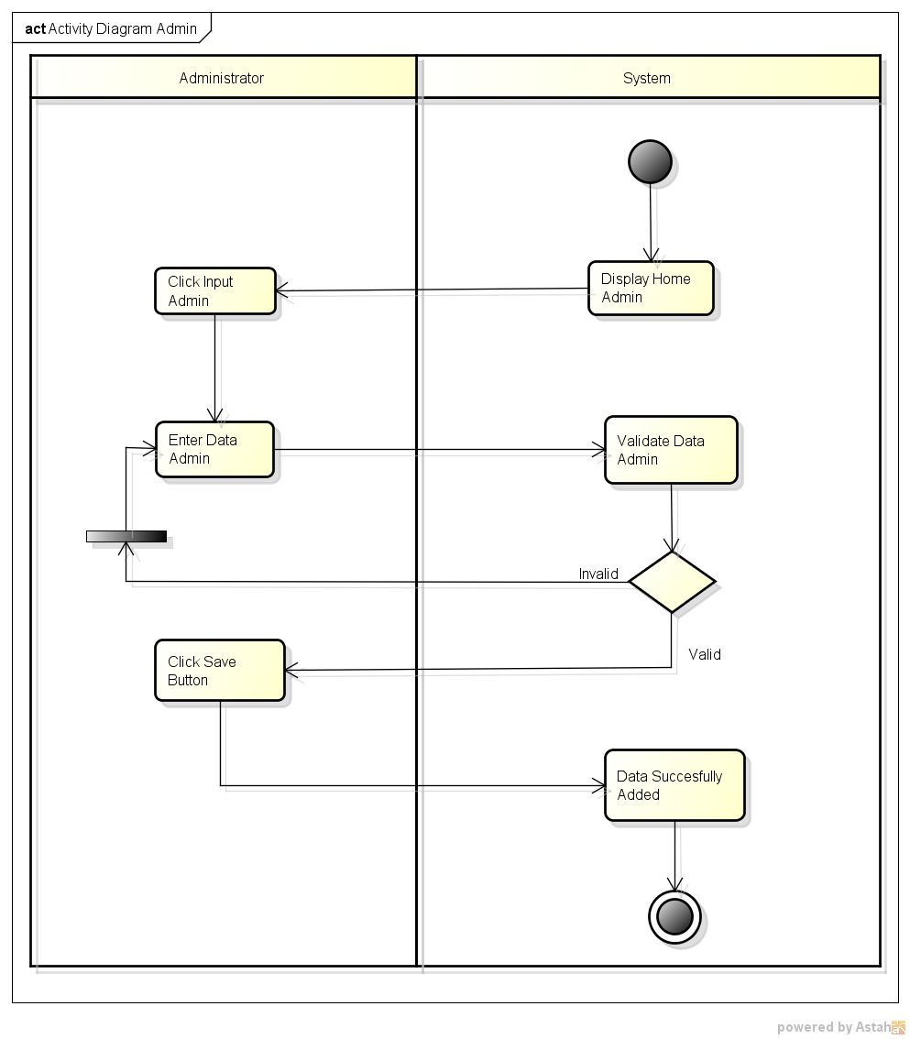

**ACTIVITY DIAGRAM UPDATE ADMIN**

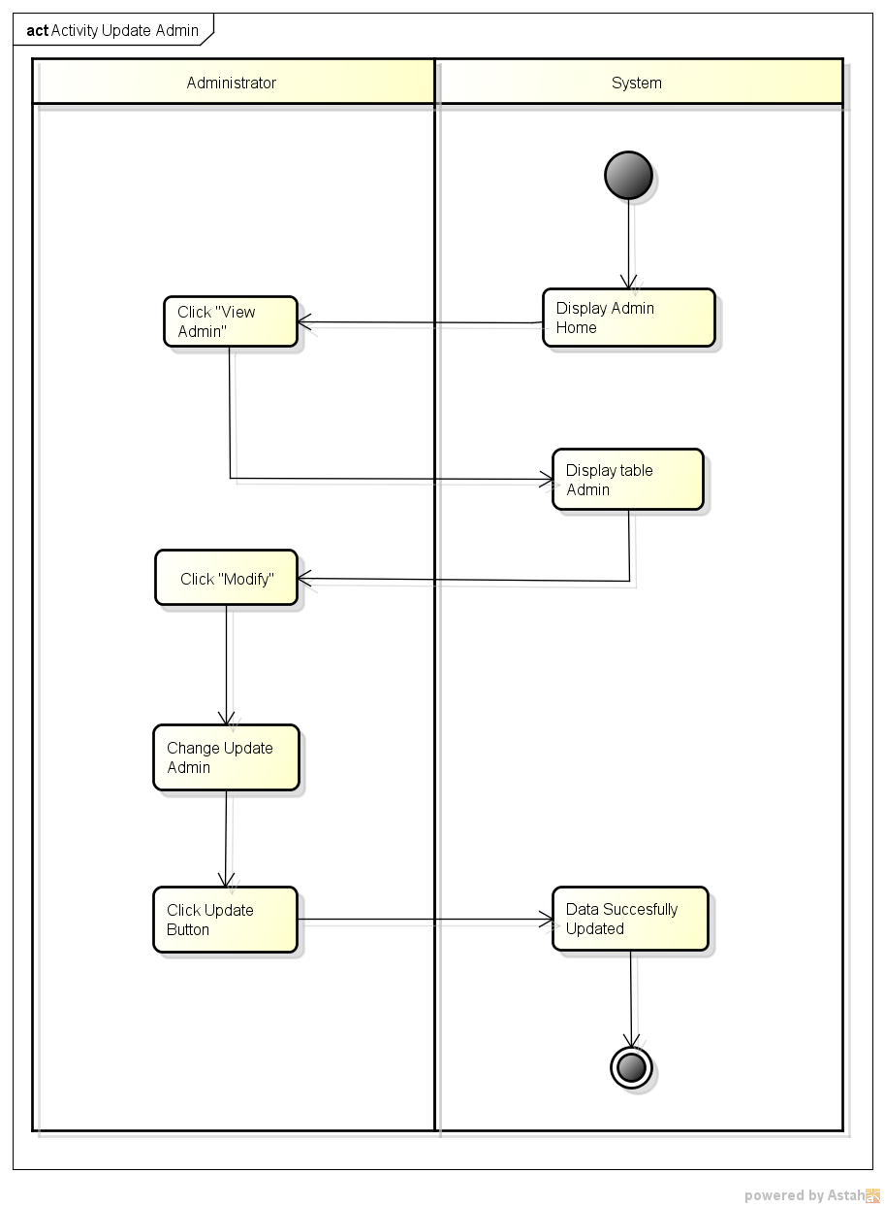

**ACTIVITY DIAGRAM DELETE ADMIN**

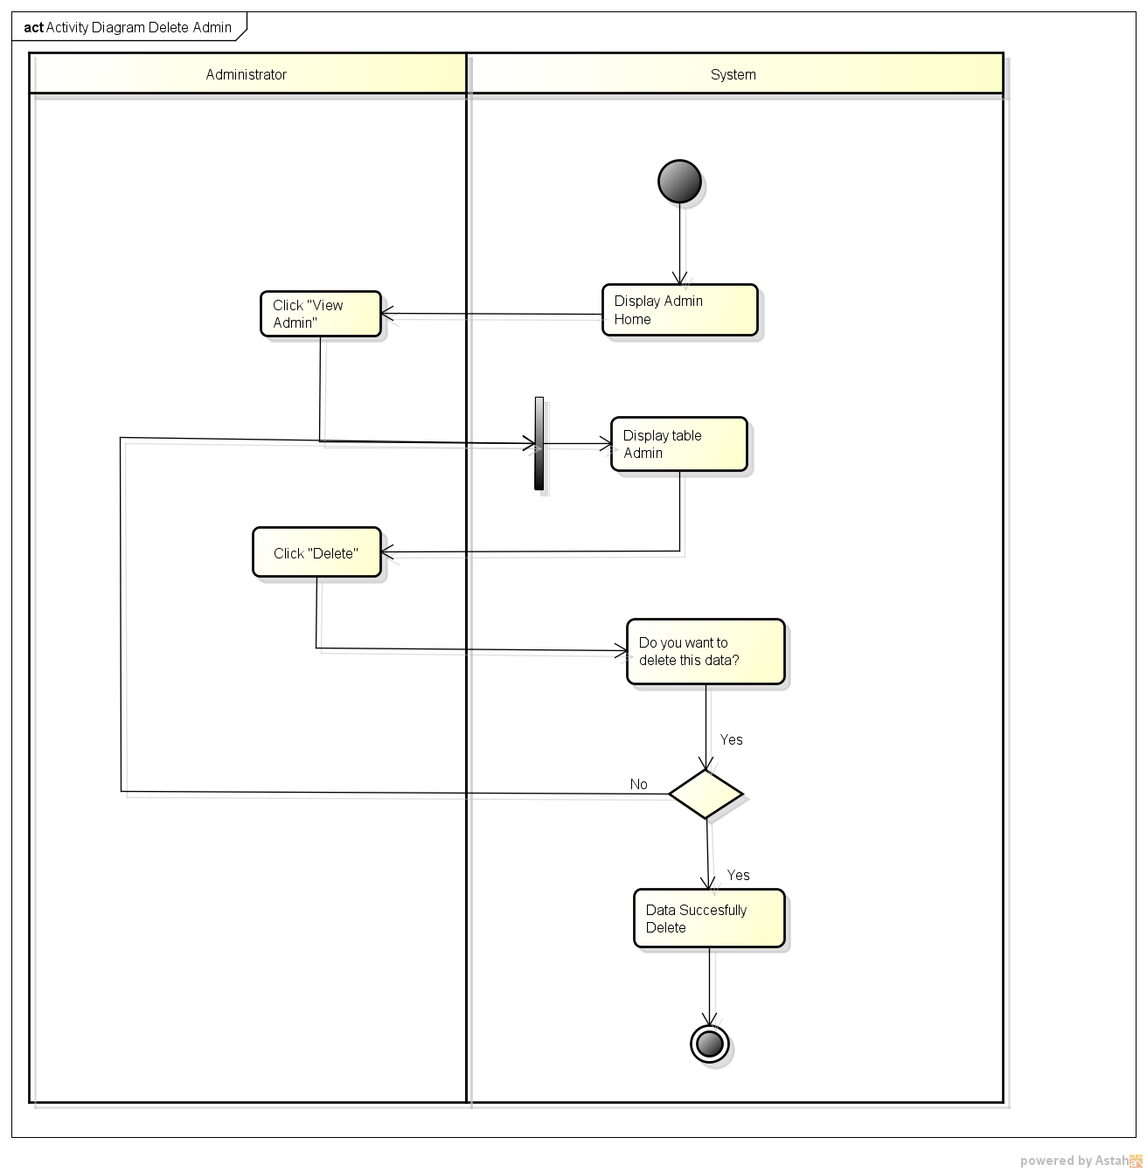

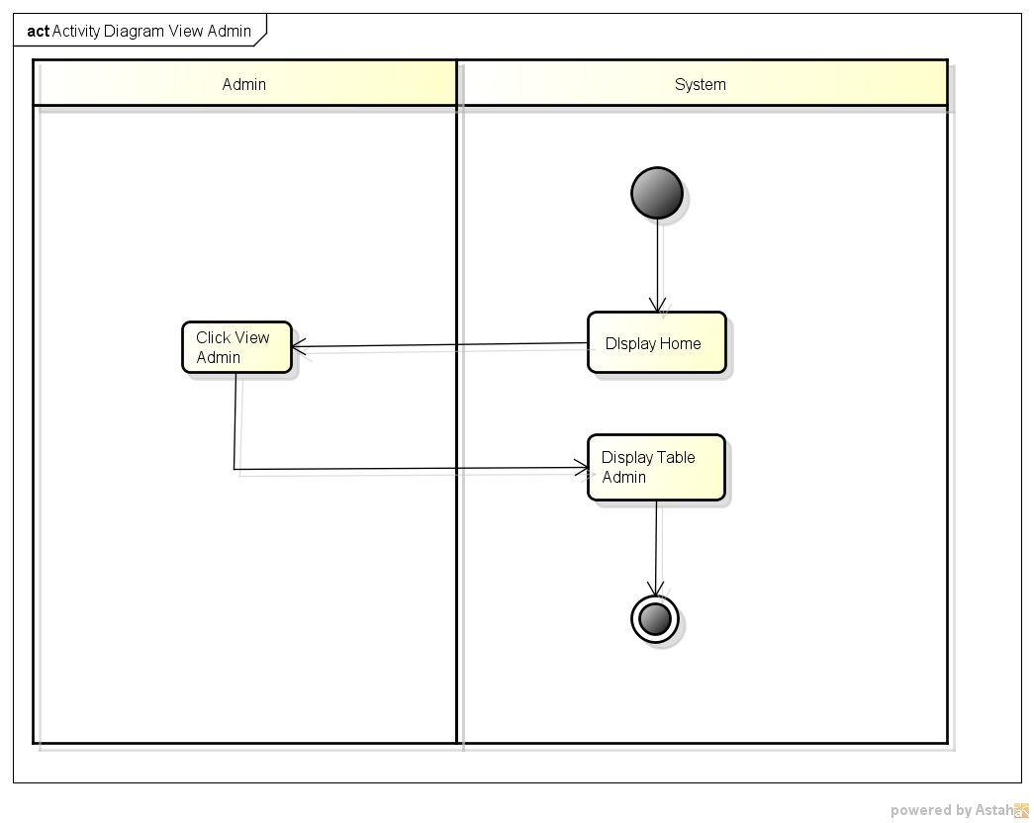

**ACTIVITY DIAGRAM VIEW ADMIN**

**ACTIVITY DIAGRAM ADD EBOOKS**

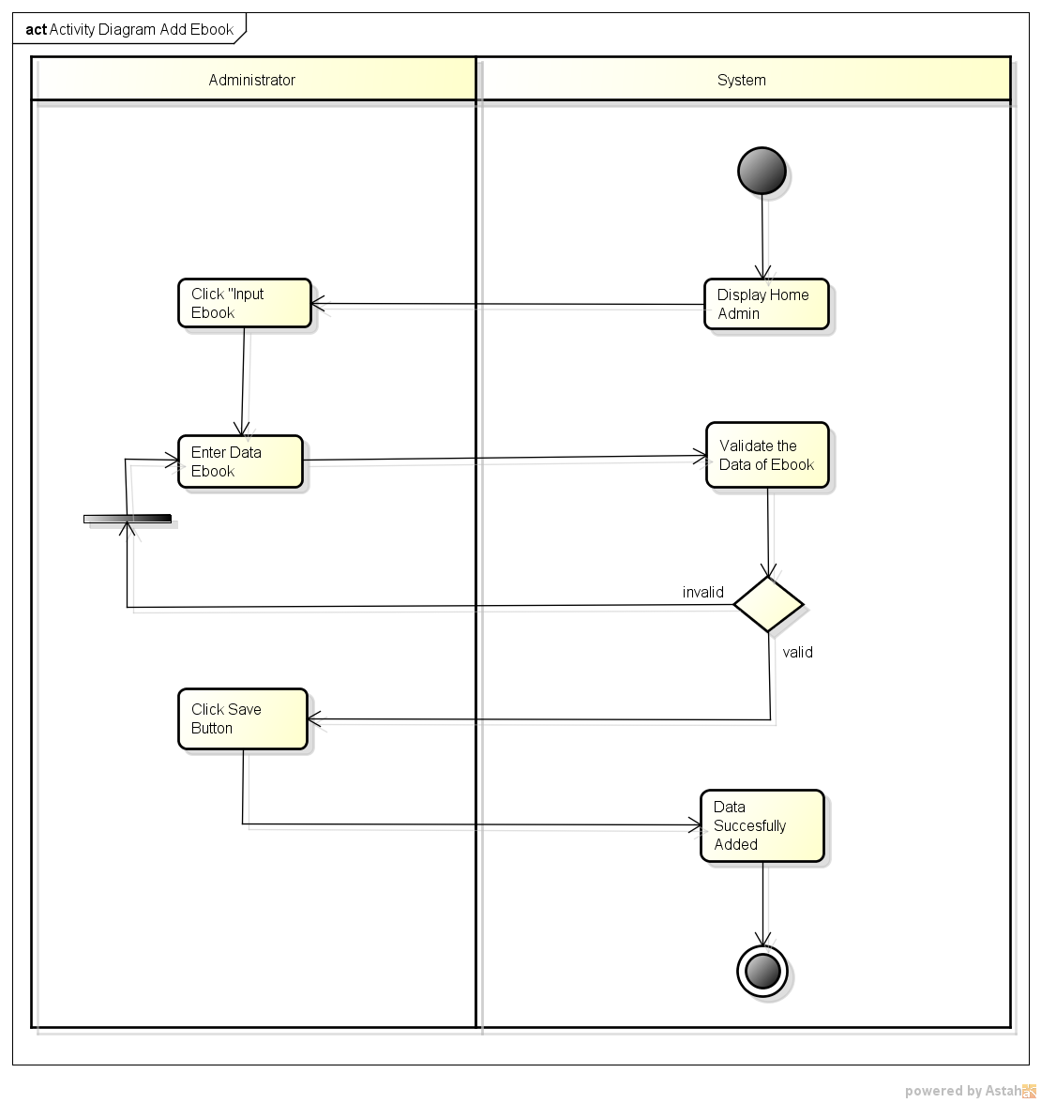

**ACTIVITY DIAGRAM UPDATE EBOOKS**

**ACTIVITY DIAGRAM UPDATE EBOOKS**

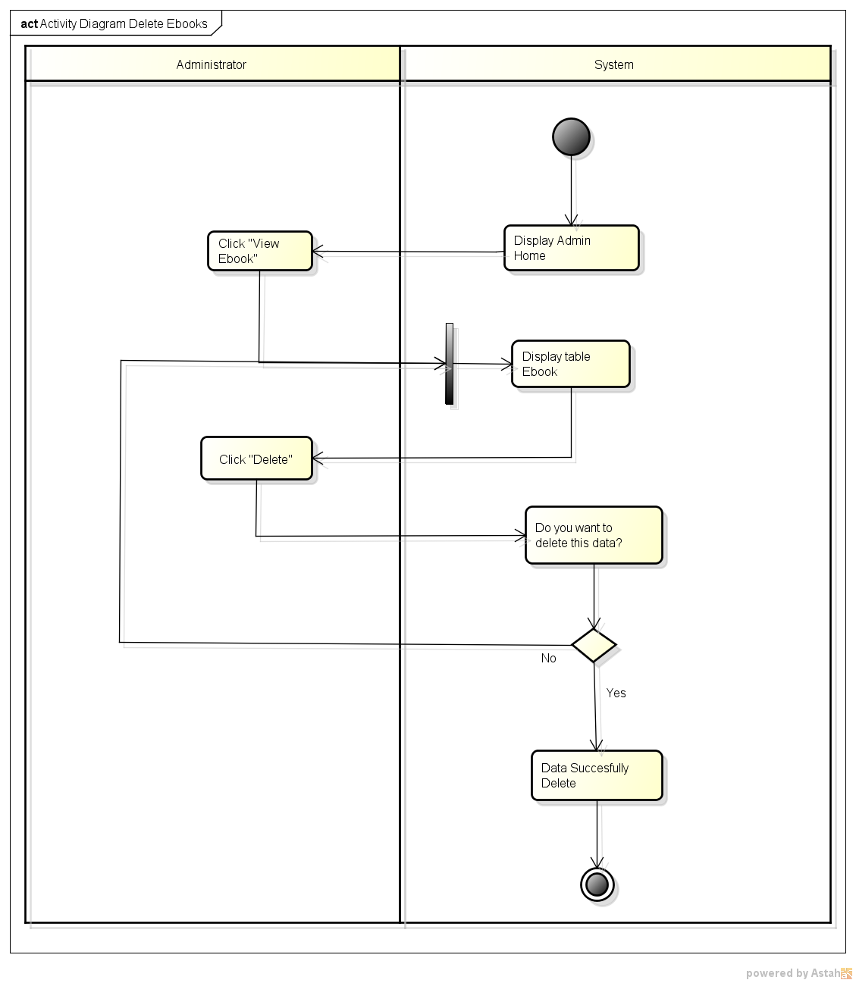

**ACTIVITY DIAGRAM DELETE EBOOKS**



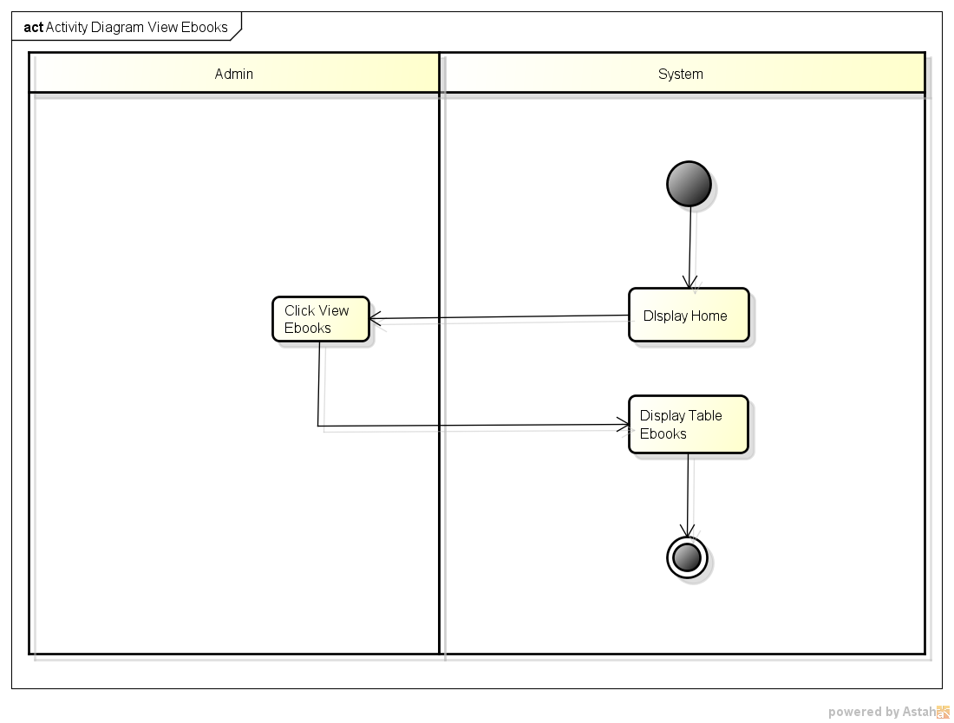

**ACTIVITY DIAGRAM VIEW EBOOKS**

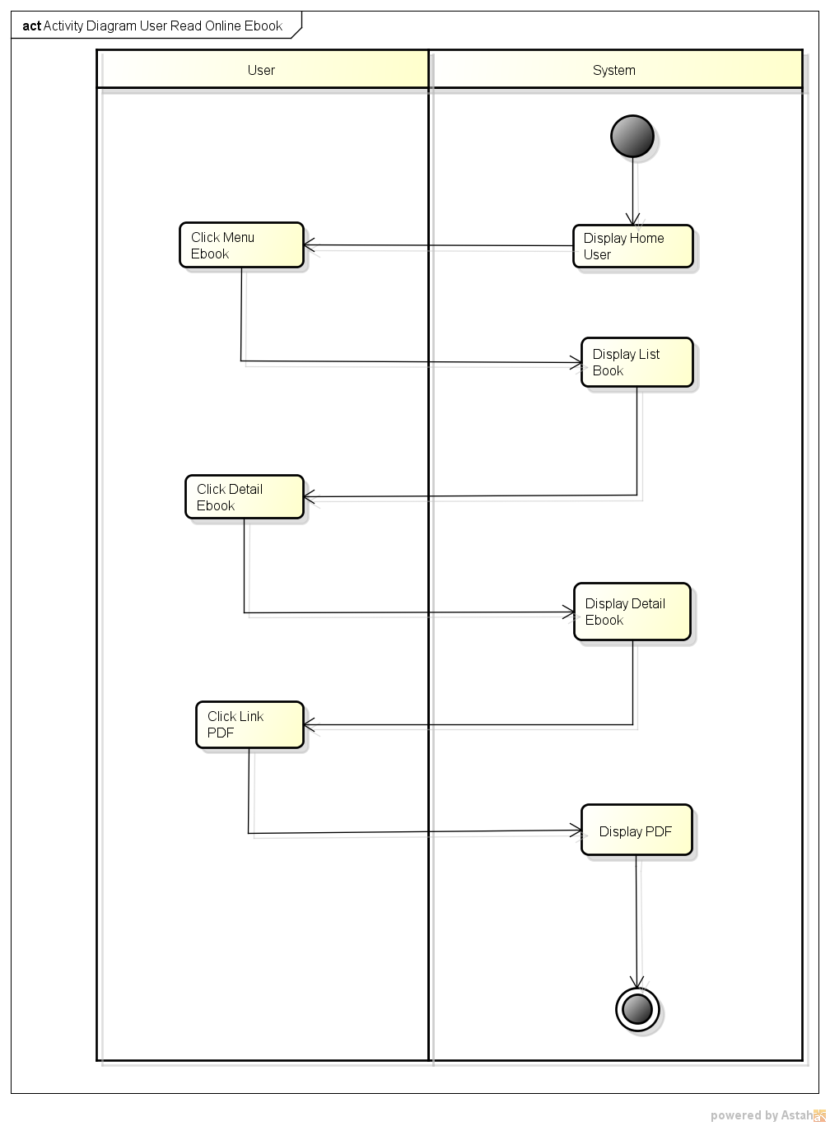

**ACTIVITY DIAGRAM USER READ ONLINE**

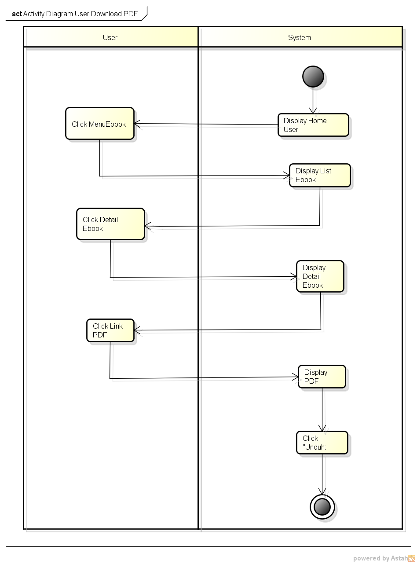

**ACTIVITY DIAGRAM USER DOWNLOAD PDF**

**USE CASE DIAGRAM USER**

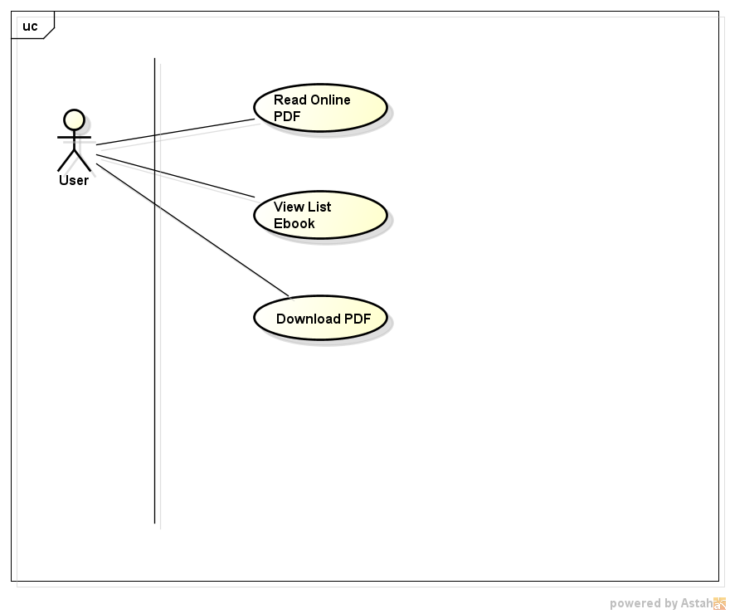

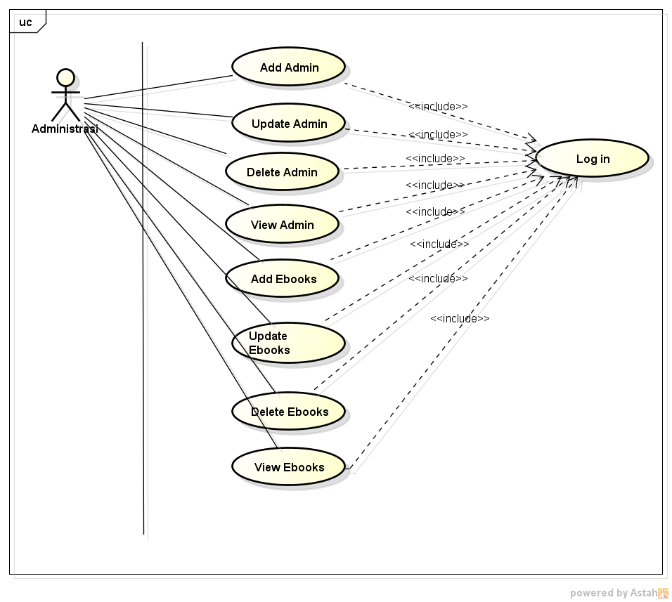

**USE CASE ADMINISTRATOR**

**Continuing Education Program Center for Computing and Information Technology**

**Fakultas Teknik Universitas Indonesia**



**EBOOKS WEB BASED APPLICATION**

Class : 4SC4

Name : 1. Jasmine Nabila Novel

2. Yansiska

Faculty : Mr. Riza Muhammad Nurman, S.Kom

Gedung Pascasarjana Lt.3 Fakultas Teknik-Universitas Indonesia

Kampus Baru UI Depok

16424